**Matlab Code For Chess Box Distance**

% Parameters

radius = 10; % Radius of the circle

center = [0, 0]; % Center of the circle (x, y)

gridSize = 20; % Grid size (for visualization)

% Create a grid of points

[x, y] = meshgrid(-gridSize:gridSize, -gridSize:gridSize);

% Calculate the chessboard (Chebyshev) distance of each point from the center

distances = max(abs(x - center(1)), abs(y - center(2)));

% Create a mask for points that lie on the "circle" boundary

circleMask = distances == radius;

% Plot the chessboard distance "circle"

figure;

hold on;

imagesc(-gridSize:gridSize, -gridSize:gridSize, circleMask); % Display the circle mask

colormap(gray);

axis equal;

title('Chessboard Distance Circle');

xlabel('X');

ylabel('Y');

hold off;

imshow;

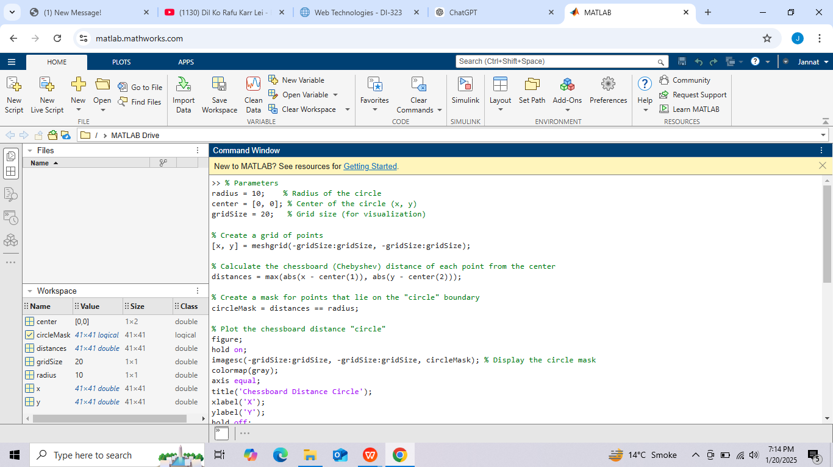

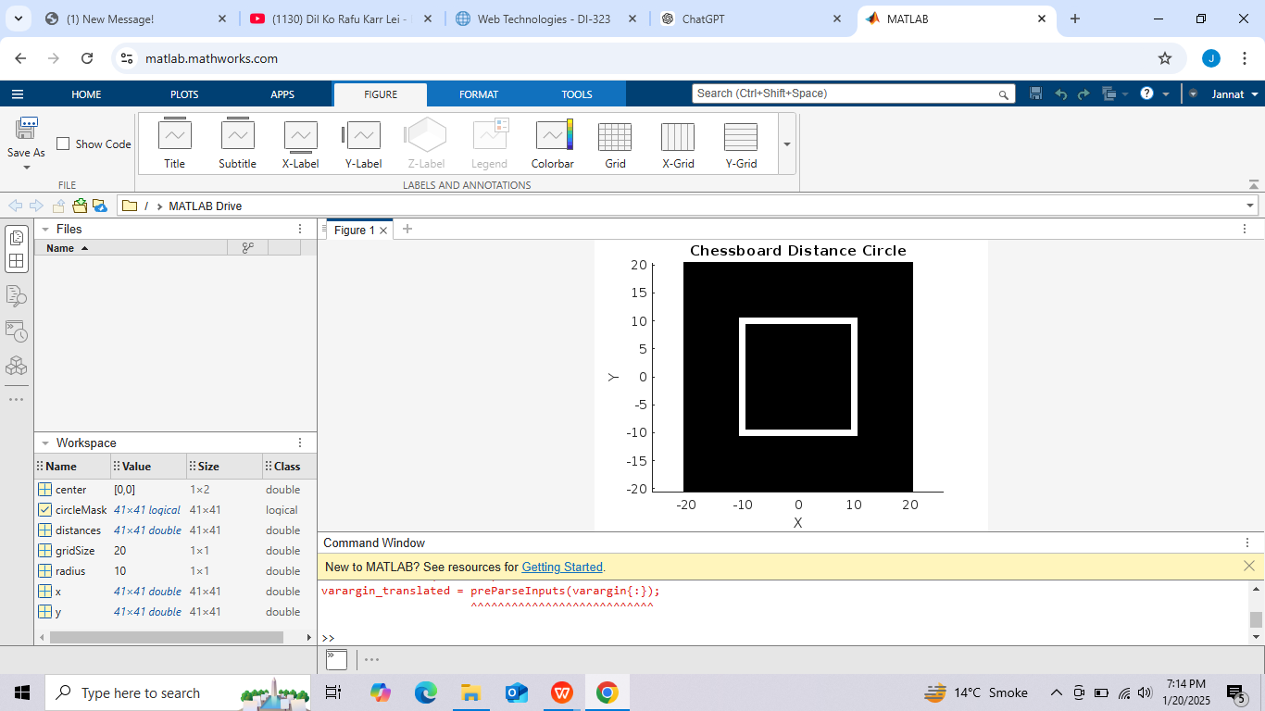

### Explanation:

* **Chessboard Distance**:

The distance between a point (x,y)(x, y)(x,y) and the center (x0,y0)(x_0, y_0)(x0​,y0​) is calculated as: distance=max⁡(∣x−x0∣,∣y−y0∣)\text{distance} = \max(|x - x_0|, |y - y_0|)distance=max(∣x−x0​∣,∣y−y0​∣)

* **Boundary Mask**:

A logical mask selects points where the distance equals the specified radius.

* **Visualization**:

The resulting shape is a square, reflecting the nature of chessboard movement, where a "circle" includes all squares reachable within the given distance.

The plot will show a square centered at the origin with side lengths determined by the specified radius.